|  |  |
| --- | --- |
|  |  |

**REVIEWED SYSTEM REQUIREMENTS SPECIFICATIONS (SRS) DOCUMENT FOR THE DEVELOPMENT OF TANZANIA CHAMBER PORTAL (TCP)**

**Reviewed by:**

Kalen Limited

10th Floor, PSSSF Commercial Complex Sam Nujoma Road,

Dar es Salaam Tanzania

Email: info@kalen.co.tz Mob: +255 748 000 081

[www.kalen.co.tz](http://www.kalen.co.tz)

|  |  |
| --- | --- |
|  |  |
| **Document No** | 2 |
| **Version** | 1.2 |
| **Date of Issue** | 9 June 2025 |

# Document Control

**Ownership**

|  |  |
| --- | --- |
| Name | Designation |
|  |  |
|  |  |
|  |  |

**Approval**

|  |  |  |  |
| --- | --- | --- | --- |
| Name | Designation | Signature | Date |
|  |  |  |  |
|  |  |  |  |

**Amendment History**

|  |  |  |
| --- | --- | --- |
| Version | Date | Description |
| 1.0 | 09 May 2025 | Document Creation |
| 1.1 | 09 June 2025 | Document Revision |

# List of Abbreviations and Acronyms

|  |  |
| --- | --- |
| API | Application Programming Interface |
| BDO | Business Development Officer |
| BRD | Business Requirements Document |
| BRELA | Business Registrations and Licensing Agency |
| CFA | Clearing and Forwarding Agency |
| CoO | Certificate of Origin |
| GD | Government Departments |
| HQ | Headquarter |
| HTML | Hyper Text Mark-up Language |
| HTTP | Hypertext Transfer Protocol |
| ICT | Information and communication Technology |
| IT | Information Technology |
| LATRA | Land Transport Regulatory Authority |
| NIDA | National Identification Authority |
| NTB | Non-Tariff Barrier |
| OGD | Other Government Departments |
| OTP | One Time Password |
| REO | Regional Executive Officer |
| RO | Regional Office |
| SDD | System Design Document |
| SLA | Service Level Agreement |
| SMS | Short Messaging Service |
| SQL | Structured Query Language |
| SRS | System Requirement Specifications |
| SSL | Secure Sockets Layer (SSL) |
| TAFFA | Tanzania Freight Forwarders Association |
| TBS | Tanzania Bureau of Standards |
| TCCIA | Tanzania Chamber of Commerce Industry and Agriculture |
| TCP | Tanzania Chamber Portal |
| TIN | Taxpayer Identification Number |
| TLS | Transport Layer Security |
| TMA | Trademark Africa |
| TPF | Tanzania Police Force |
| TRA | Tanzania Revenue Authority |
| URL | Uniform Resource Locator |

# Table of Contents

Document Control ii

List of Abbreviations and Acronyms iii

Table of Contents iv

1 Introduction 1

1.1 Background 1

1.2 Rationale 1

1.3 Purpose Description 1

2 TCP Systems Description 2

2.1 TCP User classes 3

2.2 TCP Actors and Responsibilities 3

2.3 Stakeholders 6

2.4 Business Rules 7

2.5 TCP Processes Overview 12

3 Solution Architecture 13

3.1 Solution Concept Diagram 13

3.2 Solution Architecture Diagram 15

4 Proposed To-Be Processes 17

4.1 User Management 17

4.1.1 User Create Own User Account 17

4.1.1.1 Process flow diagram 17

4.1.2 Admin Create User Account 18

4.1.2.1 Process flow diagram 18

4.1.3 Create Password 18

4.1.3.1 Process flow diagram 18

4.1.4 Login 19

4.1.4.1 Process flow diagram 19

4.1.5 Change Password 20

4.1.5.1 Process flow diagram 20

4.1.6 Reset Password 21

4.1.6.1 Process flow diagram 21

4.1.7 Verify User’s Email Account 22

4.1.7.1 Process flow diagram 22

4.1.8 Send Notification 22

4.1.8.1 Process flow diagram 23

4.1.9 Deactivate User Account 23

4.1.9.1 Process flow diagram 23

4.1.10 Activate User Account 24

4.1.10.1 Process flow diagram 24

4.1.11 Create Role 24

4.1.11.1 Process flow diagram 25

4.1.12 Assign Permission to Role 25

4.1.12.1 Process flow diagram 25

4.1.13 Assign Role to User 25

4.1.13.1 Process flow diagram 26

4.2 Certificate of Origin Management 26

4.2.1 Manager registration 26

4.2.1.1 Process flow diagram 26

4.2.2 Firm registration 27

4.2.2.1 Process flow diagram 27

4.2.3 Officer registration 28

4.2.3.1 Process flow diagram 29

4.2.4 CFA Selection 29

4.2.4.1 Process flow diagram 29

4.2.5 Application for factory verification 30

4.2.5.1 Process flow diagram 31

4.2.6 Certificate of Origin 33

4.2.6.1 Process flow diagram for the COO application starts from TANCIS/Single window 33

4.2.6.2 Process flow diagram for the COO application starts from TCCIA 35

4.2.7 CFA manager registration 37

4.2.7.1 Process flow diagram 37

4.2.8 CFA Officer registration 38

4.2.8.1 Process flow diagram 39

4.3 Membership 39

4.3.1 Membership Application 39

4.3.1.1 Process flow diagram 40

4.3.2 Membership Renewal/Reinstatement 42

4.3.2.1 Process flow diagram 42

4.3.3 Managing product and service catalogue 42

4.3.3.1 Process flow diagram 43

4.3.4 Assigning product and service to the membership category 43

4.3.4.1 Process flow diagram 44

4.3.5 Removing product and service from a given membership category 45

4.3.5.1 Process flow diagram 45

4.4 Non-Tariff Barrier Management 45

4.4.1.1 Process flow diagram 46

4.5 Complaints handling 47

4.5.1.1 Process flow diagram 48

4.6 Handover duties 49

4.6.1.1 Process flow diagram 49

4.7 Billing and Payments 50

4.7.1 Bill and Payments 50

4.7.1.1 Process flow diagram 50

4.7.2 Bill cancellation 51

4.7.2.1 Process flow diagram 52

4.7.3 Identification of Defaulters 52

4.7.3.1 Process flow diagram 53

4.7.4 Payment Reminder Notification 53

4.7.4.1 Process flow diagram 54

4.7.5 Payment Via Prepaid Service 54

4.7.5.1 Process flow diagram 55

5 System Constraints 56

6 Assumptions and Dependencies 59

7 Project Implementation Constraints 60

8 Requirements for Development of TCP 62

8.1 Functional Requirements 62

8.1.1 User Registration 62

8.1.2 Core processes requirements 64

8.1.3 Integration Needs 70

8.1.3.1 Data to be exchanged 70

8.1.3.2 System integration requirements 71

8.1.4 System configuration requirements 72

8.2 Non-Functional Requirements 73

8.2.1 Performance Requirements 73

8.2.1.1 Workload Management 73

8.2.1.2 Response Time 74

8.2.2 Scalability 74

8.2.3 Usability 75

8.2.4 Platform 76

8.2.5 System Quality Attributes 76

8.2.5.1 Availability and Reliability 76

8.2.5.2 Backup and Recovery Management 77

8.2.5.3 Maintainability 77

8.2.5.4 Portability 78

8.2.6 Testing Requirement 79

8.2.7 System Administration, Security and Management Requirements 79

8.2.7.1 System Administration 79

8.2.7.2 System Security 80

8.2.7.3 Virus, Spam-ware and Spy-ware Protection 84

9. Appendices 86

8.1 Reports Specifications 86

# Introduction

## Background

This TCCIA Software Requirements Specification (SRS) document serves as a comprehensive blueprint that outlines the functional and non-functional requirements of proposed Tanzania Chamber Portal (TCP). It ensures a clear understanding among stakeholders such as TCCIA staff, Regional Executive Officers (REOs), Exporters, Clearing and Forwarding Agency (CFA) Officers, members and so on and guides the development team on what features to prioritize, helps prevent scope creep, enhances communication and collaboration. Further, this SRS document serves as a basis for testing and validation, and ultimately contributes to the successful delivery of a high-quality TCP.

## Rationale

The pursuit of process improvement for TCCIA is rooted in the mission to promote and facilitate trade, industry, and agriculture in Tanzania. Recognizing the dynamic and ever-evolving nature of international trade and commerce, both organizations are committed to staying at the forefront of innovation and efficiency.

In the past, TMA has supported TCCIA on various trade facilitation interventions, including the digitization of the application and administration process for the certificate of origin - a critical document in international trade that certifies the origin of goods and reporting of Non – Tariff Barriers (NTBs) and TCCIA membership system. With such support from TMA, it is evident that TCCIA has embraced ICT as a strategically transformative instrument in improving simplification, efficiency and transparency of services offered by government organizations to investors and citizen at large. It is with this in mind that TMA aims to comprehensively review, map, and identify opportunities for improvement within TCCIA’s existing business processes. This includes identifying areas of process re-engineering and opportunities for gains through process improvement and digitization/automation.

## Purpose Description

Trademark Africa (TMA) in collaboration with TCCIA need to design and develop a system that will automate all its core business processes to ensure improvement of service delivery to the internal and external stakeholders. The latter includes both, local and international stakeholders. The system to be developed shall be a web-based application and a mobile app that guarantee improved accessibility and availability of TCCIA services to traders and other stakeholders.

The automation of TCCIA core business processes shall enhance the ease of doing business for its members, reduce trade barriers, and bolster the competitiveness of Tanzanian businesses in the global market. Through automation and process optimization, TCCIA envisions a future where its internal and external stakeholders can navigate trade procedures with greater ease, experience faster and more transparent services, and, ultimately, foster economic growth and development in Tanzania. The following are the key business objectives for this project:

1. To provide remote accessibility and availability of a single integrated system to internal and external stakeholders through a web portal and mobile app.
2. To reduce the turnaround time of core business operations by ensuring all submitted applications, processes and produced certificates are trackable and adhere to TCCIA service delivery charter.
3. To ensure a high level of compliance amongst its internal and external stakeholders with internal guidelines, policies, procedures, regulatory frameworks and international standards.
4. To ensure seamless payment collection from external stakeholders through payment gateway with multiple payment solutions.
5. To generate detailed reports of various business operations performed by TCCIA internal and external stakeholders.

# TCP Systems Description

This section describes the system's user types, outlines privileges associated with each role, provides a comprehensive list of business rules that will support various controls within TCP and describe processes overview using process map diagram and description.

## TCP User classes

This section details the main categories of end users for the TCP.

Table 1: TCP User Categories

|  |  |  |
| --- | --- | --- |
| **S/N** | **User Category** | **Description** |
| 1 | Internal User (Staff/Employee) | This category encompasses staff members within TCCIA who will interact with the TCP to manage various aspects of certification, membership, NTB and other TCP processes. These users include administrative personnel, technical staff, inspectors, and management. |
| 2 | External User (Client) | This category encompasses Companies and Individuals outside of TCCIA who interact with the TCP. These users include members, manufacturers, traders, agents and other stakeholders involved in trade, policy makers and the general public. |

## TCP Actors and Responsibilities

The table below details the privileges associated with each role within the TCP.

Table 2: TCP Actors and Privileges

|  |  |  |
| --- | --- | --- |
| **S/N** | **User/Actor** | **Responsibility** |
|  | **Membership Officers** | Responsible for all operations related to membership   * Manages product and service catalogue |
|  | **Membership Manager** | Responsible to oversee and manage all operations related to membership.   * Manages membership categories * Assigns product and service to membership category * Removes product and service from membership category |
|  | **CoO Evaluators** | Responsible for receiving CoO applications, scrutinizing it and facilitate payment and issuance of CoO to the applicant |
|  | **Authorized Signatories** | Responsible for signing CoO certificates. Their signatures are also present in customs office of all countries receiving CoO applications from Tanzania.   * Evaluates CoO application |
|  | **Regional Executive Officers** | Responsible to oversee TCCIA operations at regional level. There are 26 REOs from 26 regions of Tanzania mainland. The main operations are related to memberships services, CoO services and NTBs reporting   * Assigns regional contact person(s) to GD * Removes regional contact person from a given GD * Forwards reported NTB to regional GD contact person(s) |
|  | **HQ NTB Officers** | Responsible for receiving and evaluating the reported NTBs. This is because, some of reported NTBs are not necessarily NTBs, can also be compliant or an enquiry. They are responsible for compiling the reported NTBs from district to national levels   * Adds Government Department (GD) names * Removes GD names * Updates GD names * Forwards reported NTB to regional GD contact person(s) |
|  | **HQ Inspector** | * Evaluates applications for factory verifications |
|  | **Inspector** | * Conduct factory verification |
|  | **TCCIA Agent/ Business Development Officer** | * Posts business opportunities to social media platforms through TCP * Share business opportunities to members through SMS and their email and TCP’s accounts * View business information through the TCP, email account and SMS * Renew membership certificate * Apply for membership reinstatement * Submits NTB |
|  | **Exporter** | * Request for verification through TRA * Registers as TCCIA customer * Apply for factory verification * Evaluates factory verification report * Submit CoO Application * Submits NTB |
|  | **Firm Manager** | Responsible for registering firms, firm’s officers, CF Agents and management of firm products   * Request for verification through TRA * Registers as TCCIA customer * Apply for factory verification * Evaluates factory verification report * Submit CoO Application * Submits NTB |
|  | **Firm Officers** | Responsible for request of product verification and CoO |
|  | **CFA Manager** | Responsible for CFA & Officer registration and CFA for customers |
|  | **CFA Officer** | Responsible for CF on behalf of Customers   * Requests verification through TRA * Registers as TCCIA customer * Submits CoO Application * Submits NTB |
|  | **Membership Applicant** | Registration, Application for service and general view of the system   * Requests for verification * Submits membership application |
|  | **Administrator** | User management, roles management, configuration management, customize reports, view reports |
|  | **ICT Admin Officer** | System Administration, Database Administration, view reports, view logs. |
|  | **Accountant** | Activate an expired invoice, cancel control number, perform reconciliation, request control number, generate revenue reports, view reports, view assigned tasks, configuration management |

## Stakeholders

Below is a list of external stakeholders

* **National Identification Authority (NIDA):** This is the Government authority that provides identity verification services that are recognized nationally and internationally. Any person that interacts with TCP should first have a valid NIDA number.
* **Business Registrations and Licensing Agency (BRELA):** This is the Government agency responsible for issuing business registration license and certificate of incorporation. Therefore, for any business entity to receive TCCIA services should have an active Certificate of Incorporation registered by BRELA.
* **Tanzania Revenue Authority (TRA):** The Customs Office of TRA is the Government custodian of issued CoO. Once reviewed, approved, or issued by TCCIA, all Certificates of Origin (CoOs) will be transmitted to the TRA system for viewing before being transferred to the destination country.

Further, TRA facilitates communications between the customs office of the destination country and TCCIA in case of any enquiry related to CoO from the destination country. In additional to that, TRA records and approves all CFAs, therefore any CFA to receive TCCIA services should first be verified by TRA. Lastly, TRA produces Tax Identification Number (TIN) for each business operating in Tanzania. Therefore, for any trader, manufacturer or exporter to receive TCCIA services should have an active Taxpayer Identification Number (TIN) registered by TRA.

* **Clearing and Forwarding Agencies (CFA):** These are the main applicants for CoO. They normally apply for CoO on behalf of exporters. However, some exporters they apply for CoO without CFA.
* **Exporters:** These are the beneficiaries of CoO. However, it is optional for exporter to apply for CoO whenever exporting the products. That is, total exports recorded by TCCIA through issued CoO is not total export of the country as some traders exports their products without CoO.
* **Embassies:** These are responsible for facilitating communications related to CoO between TCCIA (CoO producer) and destination country (CoO consumer). In most cases, the communications are enquiring related to CoO received by destination countries that need verification from TCCIA.
* **Payment Gateway:** This is a private owned technical infrastructure that provides a platform for TCCIA to generate control number for various payments and receive receipts of payment made by customers through multiple channels such as mobile banking, internet banking, cash deposits through banks or mobile payment agents.
* **Members:** These are different members registered by TCCIA across 26 regions of Tanzania mainland and beneficiary for receiving various products and services offered by TCCIA and depending on their membership category such as Gold, Silver or Bronze.
* **Non-Members:** These are prospective members that needs to receive more awareness programmes and trainings on TCCIA business operations and opportunities.
* **Government Departments for NTBs Handling:** These Government Departments are response for receiving alerts on various issues related to NTBs incidents that needs attention. For example, Tanzania Police Force (TPF), LATRA, TBS, and so on.

## Business Rules

The following business rules are recommended to ensure proper controls across all TCP processes.

Table 3: Business Rules

| **S/N** | **Business Rules Description** |
| --- | --- |
|  | The system shall allow system users to create own accounts and the login credentials shall be sent to the user email address |
|  | The system shall allow Admin to create system user account and the login credentials shall be sent to the user email address |
|  | The system shall allow user to create own password for accessing the system |
|  | The system shall allow user to log in the system and access only information and perform activities related to the assigned role |
|  | The system shall allow a user to change a password at any time but also after a given period of time, may be three months the system shall enforce internal users to change passwords. |
|  | The system shall allow a user to reset password whenever the need arises by providing the email address registered with email account and the new password shall be best sent be sent to the user’s email account. |
|  | The system shall automatically verify the correctness and the provided email address during user account creation |
|  | The system shall automatically generate and send notifications to the user. These notifications can either be system, email or SMS depending on the priority of the information. |
|  | The system shall allow admin to deactivate user account at any time whenever the need arises |
|  | The system shall allow admin to activate user account at any time whenever the need arises |
|  | The system shall allow admin to create user roles and assign permissions to the created user roles |
|  | The system shall allow admin to assign one or more roles to a user |
|  | The system shall allow Membership Officer to add, remove and update a list of products and services offered by the chamber. |
|  | The system shall allow Membership Manager to add, remove and update a list of membership categories such as gold, silver and bronze. |
|  | The system shall allow Membership Manager to assign products and services to the created membership categories |
|  | The system shall allow REOs to append products and services to the list of products and services assigned to membership categories by Membership Manager |
|  | The system shall allow Membership Manager to remove products and services to the created membership categories |
|  | The system shall allow REOs to remove products and services appended by him or her to the list of products and services assigned to membership categories by Membership Manager |
|  | The system shall verify details of the membership application against the BRELA database in real-time. |
|  | The system shall allow membership applicant to preview the filled-in application details and confirm for application submission to complete |
|  | The system shall automatically generate membership application fee invoice depending on the submitted membership application, i.e., applicant region and membership category |
|  | The system shall automatically generate membership certificate with all necessary features such as signatures, expiry date and QR code for security purposes upon receiving payment receipt from payment gateway. |
|  | The system shall allow BDO to post business opportunities through the TPC to TCCIA official social media accounts for public consumption |
|  | The system shall allow BDO to send business opportunities to the member’s personal account through the system, email or SMS. These opportunities shall be very specific depends on the specialized business of the member. |
|  | The system shall allow member to view business opportunities received in his or her personal account. For the cases of invitations, the system shall allow the member to register for the received invitation. |
|  | The system shall allow a member to renewal membership status before expiry of the active membership status and within three (3) years after expiry date, according to TCCIA constitution. |
|  | The system shall allow a lost member (3 years after expiry date of membership status) to apply for membership reinstatement. Such membership certificates shall have new membership certificate number. |
|  | The system shall allow traders, CFAs, Exporters, and Manufacturers to register as customers. Their account details shall be verified in real-time against the existing databases at TRA and BRELA. |
|  | The system shall allow a customer to apply for factory verification and HQ inspector shall inform the customer through system and email notifications about the verification schedule and list of inspectors. |
|  | The system shall allow the inspector to fill-in the factory verification report and the report shall be operational after approver by the customer through the same system. |
|  | The system shall allow customer to select multiple products and HS Codes for the exporting products during the CoO application. |
|  | The system shall allow customer to preview the filled-in CoO application details and confirm for CoO application submission to complete |
|  | The system shall allow Authorized Signatory to evaluates the submitted application. Upon approval, the system shall automatically generate CoO application fee invoice depending on the submitted CoO application. |
|  | The system shall automatically generate CoO certificate with all necessary features such as signatures, expiry date and QR code for security purposes upon receiving payment receipt from payment gateway. |
|  | **Real-Time Verification** – The system shall allow Stakeholders to verify the authenticity of the CoO through: -  **a. QR Code** printed on the certificate.  **b. Online Verification** via the specified path: -   * + - Visit TCP Portal     - Click on *Certificate of Origin* tab     - Select *Verify Certificate*     - Enter the CoO Certificate Number and Captcha code     - Click *Verify Certificate* to view details. |
|  | The system shall automatically send the generated CoO certificate to TRA Customs Office through API (system’s integration) and therefore, the customer shall not be required to physically submit the CoO certificate to TRA customs office. |
|  | The system shall allow HQ NTB Officer to add, update and remove the names and descriptions of the relevant Government Departments that are responsible for handling reported NTBs at regional levels. |
|  | The system shall allow REO to register contacts details such as name, mobile number and e-mail address of person(s) from Government Departments responsible for handling reported NTBs in the corresponding region. |
|  | The system shall allow REO to remove the entered contacts details such as name, mobile number and e-mail address of person(s) from Government Departments responsible for handling reported NTBs in the corresponding region. |
|  | The system shall allow trader or exporter to submit NTB through SMS, mobile app, or the system and forward the reported NTB to the relevant REO and HQ NTB Officer for further actions. |
|  | The system shall allow REO to send the reported NTB by trader/exporter to the contacts from GD responsible for handling NTBs in the corresponding region, and later provide the feedback on the reported NTB. |
|  | The system shall allow HQ NTB Officer to send the reported NTB by trader/exporter to the REO and contacts from GD responsible for handling NTBs in the relevant region, and later provide the feedback on the reported NTB. |

## TCP Processes Overview

The following figure gives a clear illustration of the main processes in the TCP and further provides clustering of sub-processes in various main processes.

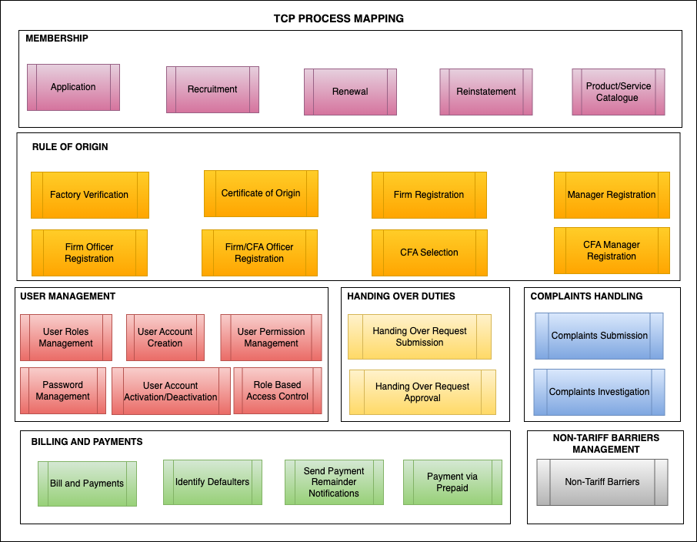

Figure 1: TCP processes map

# Solution Architecture

## Solution Concept Diagram

This section provides a conceptual diagram of the core TCP modules and interacting components, i.e., people and external systems

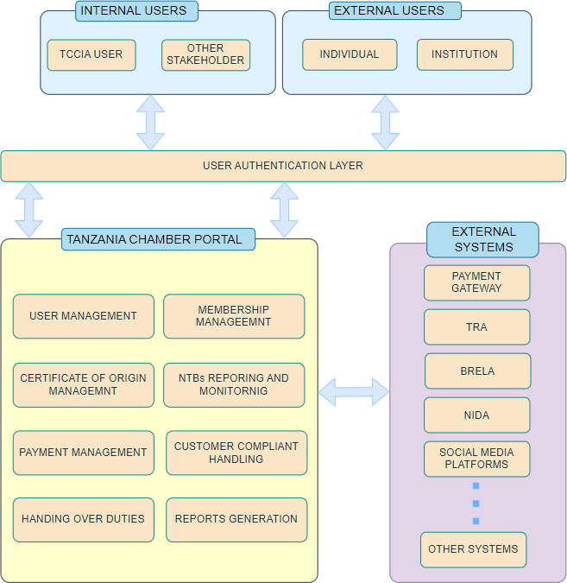

The TCP conceptual diagram is an illustration depicting the arrangement and relationships of key entities within the system. The concept diagram aims to aid an easy understanding of the system, its entities, relationships, and so on.

The TCP diagram takes the current understanding of the Tanzania Chamber Portal, helps in identifying priorities, system values and creates a shared vision. The use of a concept diagram in this document is:

1. To help communicate key messages and visualize system data, key entities and relationships.
2. To provide a better understanding of the ‘big picture’ that can’t be captured in a single diagram.
3. To span technical boundaries and language barriers between the user department and technical team.
4. To better define technical terms that are ambiguous by committing the image to the message being communicated.

The TCP concept diagram consists of the following key entities and relationships:

**Internal Users:** Internal users are those within TCCIA who shall use TCP to make day-to-day decisions. Internal users may include Membership Officer, Business Development Manager, Help Desk Officer, Factory Verification Officer, REO, Authorized Signatory and other employees who use the TCP to facilitate TCCIA operations.

**External Users:** External users are those outside of TCCIA who use the TCP to perform various actions related to TCCIA operations. For example, individual customer or CFA applying for CoO, Corporate Member registering for Presidential Delegation for business travels, or Trader reporting NTB incident, and so on.

**The User Authentication Layer:** this layer verifies the identity of a user attempting to gain access to TCP resources by authorizing a human-to-machine transfer of credentials during interactions on a network to confirm a user's authenticity. It will be used to authenticate individuals before granting access to the TCP and will require two or more proofs of identity for validation.

**External Systems:** these include all the existing systems and platforms that supporting TCCIA core business operations through data exchange. These systems may either receive data from TCP, or both, i.e., receive and send data to TCP. For example, TRA shall be both, receiving and sending of data when verifying CFA and CoO sharing while social media platforms such as Facebook, Instagram and LinkedIn shall be posting business opportunities received from TCP.

## Solution Architecture Diagram

This section presents the TCP process flow diagram that captures all necessary interactions for successful operations of the proposed system. Further, the diagram elaborates the technical components of the system. For example, the TCCIA_Engine shall contain the workflow, business logic and API. The latter shall also facilitate the interactions between TCP and the other existing external systems. Further, the diagram depicts the internal and external portals, the former is for internal users while the latter is for external users. However, both portal shall be accessible through Computer and Mobile Application. Therefore, customers shall be able to interact with the system through mobile phones and factory inspectors shall be to interact with the system through mobile applications on mobile phones or tablets.

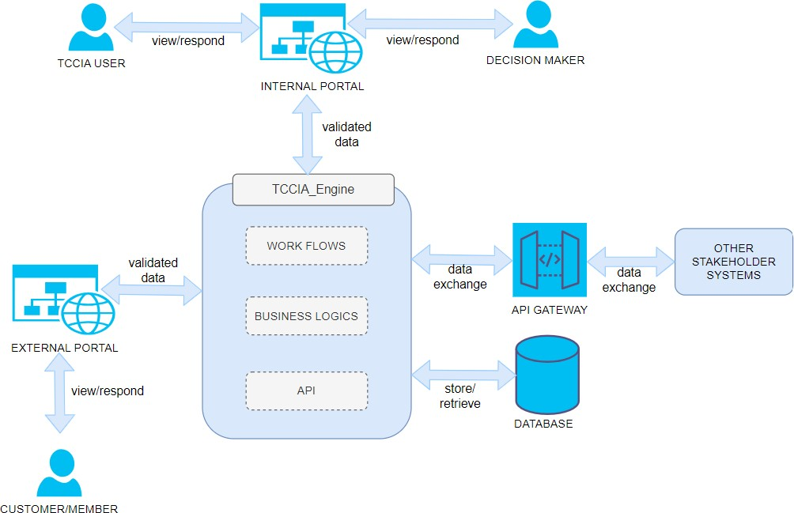

**Figure 2:** Solution Architecture

This TCP architectural diagram represents a high-level overview of a modular and secure information system, organized into five distinct layers: User Interface Layer, Application Layer, Data Layer, security layer and Integration Layer. Each layer plays a critical role in ensuring seamless interaction, efficient processing, secure communication, and integration with external services. Below is a brief explanation of each layer

# Proposed To-Be Processes

## User Management

### User Create Own User Account

1. User fills out the registration form and submits
2. The system checks if the submitted user details (e.g., username, email) already exist in the system. If the details already exist, notification is sent to user
3. If the details are new, the system proceeds to verify the submitted email by sending verification link
4. If the email is successfully verified, the system creates a new user and send activation link to user e-mail.
5. The user clicks on the link to activate the account.

#### Process flow diagram



### Admin Create User Account

1. The admin navigates to account creation link and enter user details.
2. The system shall check and notify user if submitted details already exist.
3. If the details are new, the system proceeds to verify the submitted email by sending verification link
4. If the email is successfully verified, the system creates a new user and send activation link to user e-mail.
5. The user clicks on the link to activate the account.

#### Process flow diagram



### Create Password

1. The system prompt user to insert password and confirm password through create password form.
2. The system verifies for passwords match and strength of the submitted passwords and create user password.
3. If passwords mismatch or password strength is weak, the system shall deny creating user password and notify user.

#### Process flow diagram



### Login

1. The user enters login credentials through login form and submit
2. The system shall check if submitted login credential are correct and record number of incorrect submissions.
3. If submitted credentials are correct, the system shall redirect user to the landing page.
4. If submitted credentials are incorrect, the system shall clear username and password fields.
5. The system lock user account for a while if max login attempt is reached.

#### Process flow diagram



### Change Password

1. The system enables User to enter old password, new password and confirm password through update password form.
2. The system verifies for old password, passwords match and strength of the new submitted passwords and update user password.
3. If old password is incorrect or passwords mismatch or password strength is weak, the system shall deny updating User password operation and notify User.

#### Process flow diagram



### Reset Password

1. The system enables User to submit user e-mail verified when creating account.
2. The system checks if submitted e-mail exist and send password reset link to the e-mail
3. If email doesn’t exist, the system notify user.

#### Process flow diagram



### Verify User’s Email Account

1. The system checks if user e-mail is verifiable and send activation link.
2. If email is not verifiable, the system notify user.

#### Process flow diagram



### Send Notification

1. The system checks if execution of a task is completed and sending notification is required.
2. The system obtains e-mail address or user account.
3. The system checks if e-mail or user account is verified.
4. The system send notification to verified user account or email.

#### Process flow diagram



### Deactivate User Account

1. The system allows System Admin to submit account details for deactivation.
2. The system checks if user exist and request Admin confirmation.
3. The system enables Admin to confirm requested operation.
4. The system deactivates submitted user account.

#### Process flow diagram



### Activate User Account

1. The system allows System Admin to submit account details for activation.
2. The system checks if user exist and request Admin confirmation.
3. The system enables Admin to confirm requested operation.
4. The system activates submitted user account.

#### Process flow diagram



### Create Role

1. The system enables System Admin to submit role details through create role form.
2. The system create role if it doesn’t exist.

#### Process flow diagram



### Assign Permission to Role

1. The system allows System Admin to select role from a list of predefined roles.
2. The system display permissions Admin can assign to role.
3. The system allow admin to assign permission to the selected role.
4. The system saves submitted operation.

#### Process flow diagram



### Assign Role to User

1. The system enables System admin to select user account to assign role.
2. The system displays list of predefined roles that system Admin can assign to User account.
3. The system enables System Admin to assign role(s) to selected User(s) account.
4. The system saves the submitted operation.

#### Process flow diagram



## Certificate of Origin Management

### Manager registration

The following is the process flow for registering manager for the firm

1. Manager navigate to the system and select to register
2. Applicant fills application form, preview and submit.
3. If the application is complete, the system generated login credentials and notify manager via email.
4. If the application is incomplete, notify the manager to make amendment.

#### Process flow diagram

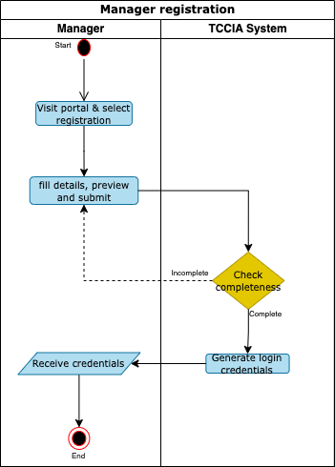

### Firm registration

The following is the process flow for registering a firm

1. Manager login to the system, navigate to firm registration, fill form details including TIN, preview and submit.
2. The system sends TIN to TRA for verification.
3. If valid TIN, the system generate OTP, sends OTP and displays manufacturer’s details
4. Manager enter OTP and submit or cancel.
5. The system checks the validity of OTP.
6. If valid OTP, system add manufacture’s details to manager’s profile.
7. If cancel, process end.

#### Process flow diagram

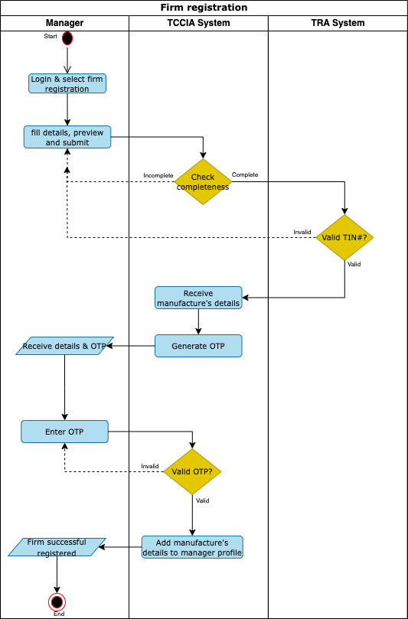

### Officer registration

The following is the process flow for registering an officer

1. Manager login to the system, navigate to officer registration, fill form details including specifying company/ies (where the officer will have roles), preview and submit.
2. If the application is complete, the system generates login credentials and notify officer via email.
3. If the application is incomplete, notify the manager to make amendment.
4. Officer receives notification, click the link, set password and submit.
5. System saves new credentials and sends notification to the officer.

#### Process flow diagram

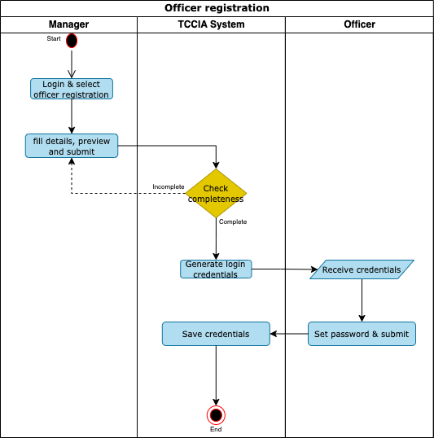

### CFA Selection

The following is the process flow for selecting a CFA

1. Manager login to the system, navigate to agent selection, select Agent, specifying company/ies (where the Agent will act on behalf), preview and approve.
2. If approved, the system sends selection notification to CFA.
3. If rejected, process end.

#### Process flow diagram

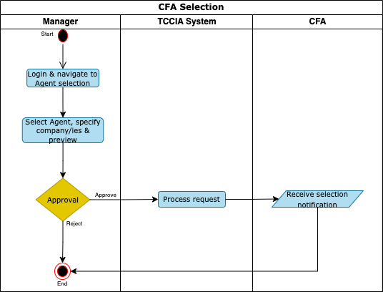

### Application for factory verification

The following is the process flow for registering a CFA

1. Applicant login into the system navigate to factory verification module and fill product details, add suggested date for inspection, upload necessary attachments, preview and submit.
2. If the application is complete, the system send notification to Industrial Manager.
3. If the application is incomplete, notify the Applicant to make amendment.
4. Industrial Manager review application, assign to REO/Qualified Inspector/s(Inspector), schedule for factory verification and submit to the Executive director for approval.
5. Executive director reviews the assigned Inspectors and approves or reject.
6. If approved, system send notification to Applicant and Inspector contains list of assigned inspectors and scheduled factory verification.
7. The Inspector conduct inspection, fills the inspection form, prepare inspection report, preview and submit to Applicant for acceptance.
8. The Applicant review the inspection report and accept/dispute.
9. If disputed, system notify Applicant to apply for another factory verification.
10. If accepted, System completes the inspection report by adding names & signature of inspector and applicant to the report, send notification to Applicant, Industrial Manager, Inspector and REO.

#### Process flow diagram

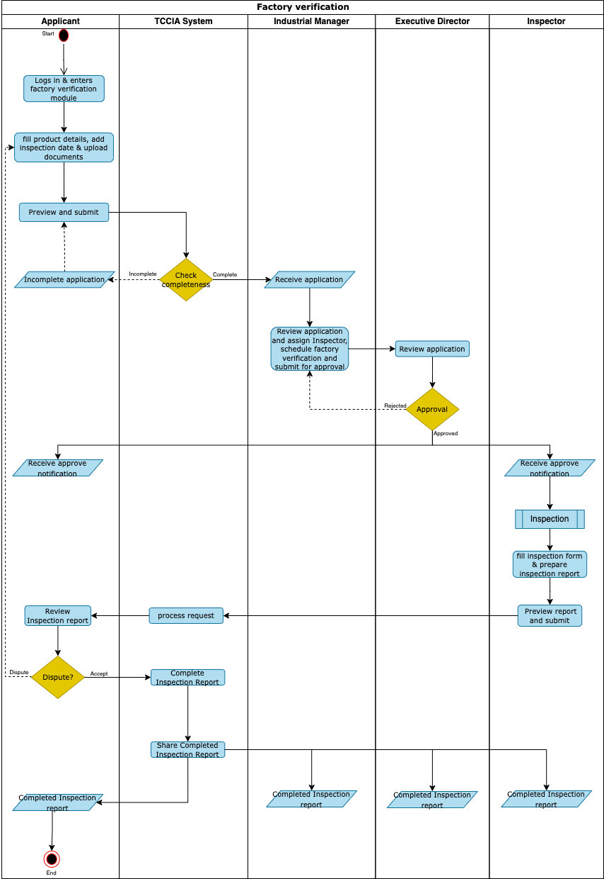

### Certificate of Origin

1. The following is the process flow when applying for certificate of origin starts from TANCIS/Single window System
2. Applicant logs into single window, navigate to apply certificate of origin (LPCO application), fill form, upload attachments and submit
3. TCCIA system receive application, check TIN number if exporter/Importer details exist
4. If TIN not exist, TCCIA send notification to applicant to register firm and factory verification to TCCIA system.
5. If TIN exist, The Evaluator review the application, recommend for approval or rejection and submit to the approver.
6. If recommended, the system generates control number and bill notification sent to Applicant.
7. The Applicant receive notification and make payment.
8. The Signatory review the application and make determination.
9. If approved, the system generates certificate of origin, share generated Certificate of origin to TRA and send notification to Applicant.
10. If rejected, the system sends rejection notification with remarks to the Applicant.

#### Process flow diagram for the COO application starts from TANCIS/Single window

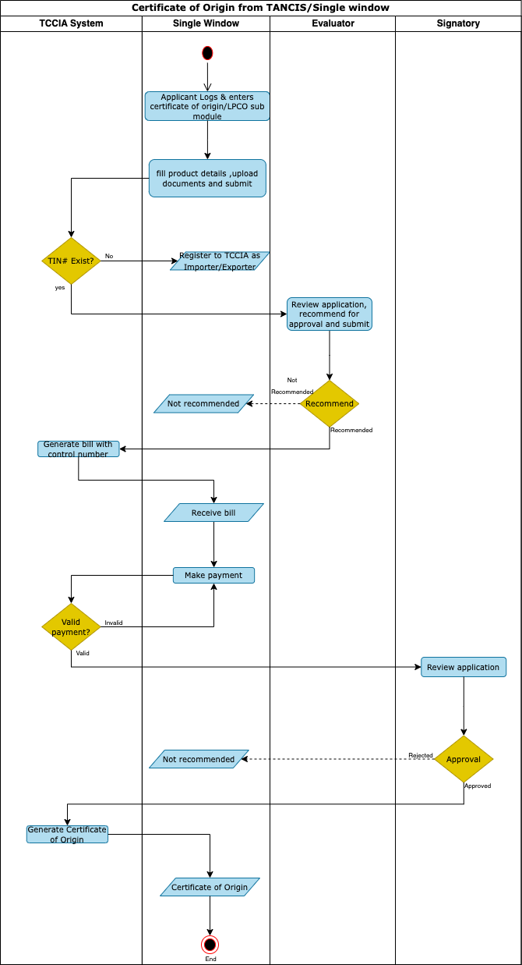

1. The following is the process flow when applying for the certificate of origin starts from TCCIA System
2. Applicant (Manager/CFA/Officer/sole proprietor) login into the system, navigate to apply for the certificate of original, select product category, fill product details, enter UCR number, upload necessary attachments and submit.
3. The system sends TRA assessment number to TRA system for verification and display export’s details for approval or rejection by Applicant.
4. If approved, the Applicant complete application form, preview and submit for evaluation.
5. The Evaluator review the application, recommend for approval or rejection and submit to the approver.
6. If recommended, the system generates control number and bill notification sent to Applicant.
7. The Applicant receive notification and make payment.
8. The Signatory review the application and make determination.
9. If approved, the system generates certificate of origin, share generated Certificate of origin to TRA and send notification to Applicant.
10. If rejected, the system sends rejection notification with remarks to the Applicant.

#### Process flow diagram for the COO application starts from TCCIA

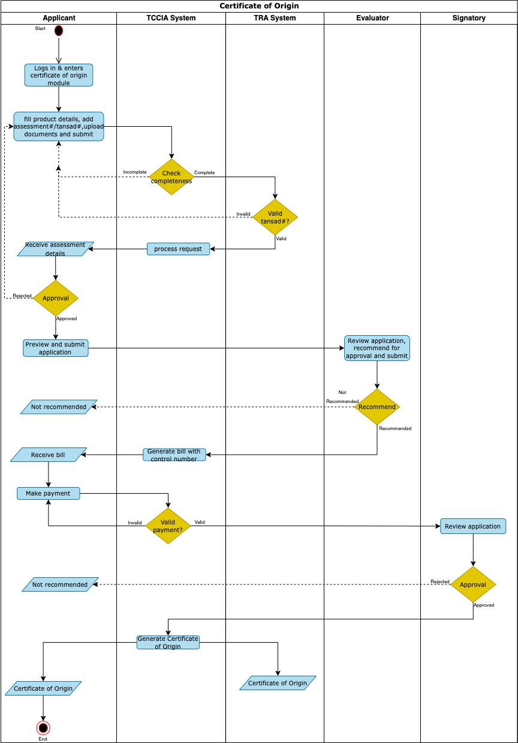

### CFA manager registration

The following is the process flow for registering as a CFA

1. The Applicant navigate to the system and select CFA registration.
2. The Applicant enter TAFFA ID number and other details.
3. The system sends TAFFA ID to TRA for verification, generate and send OTP and display CFA’s personal details and CFA’s company detail.
4. Applicant enter OTP and submit or cancel.
5. The system checks the validity of OTP.
6. If valid OTP, the Applicant complete application form, preview and submit.
7. The system generated login credentials and notify Applicant via email.
8. If cancel, process end.

#### Process flow diagram

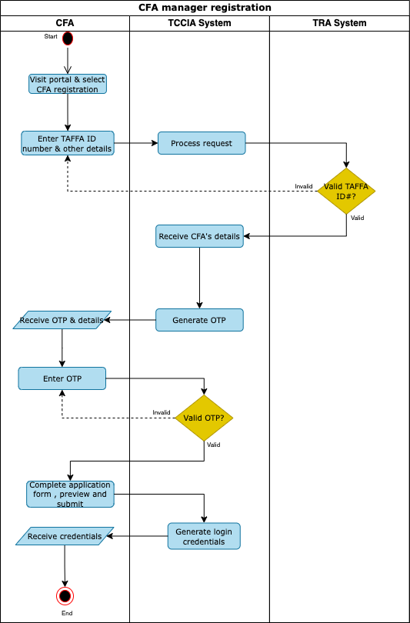

### CFA Officer registration

The following is the process flow for registering as a CFA Officer

1. The CFA Manager navigate to the system and select CFA officer registration.
2. The CFA Manager specifying company/ies, enter CFA’s officer TAFFA ID number and other details.
3. The system sends TAFFA ID to TRA for verification, generate and send OTP to CFA officer and display CFA’s officer details.
4. Applicant enter OTP and submit or cancel.
5. The system checks the validity of OTP.
6. If valid OTP, the CFA Manager complete application form, preview and submit.
7. The system generated login credentials and notify CFA officer via email.
8. CFA Officer receive notification, click the link, set password and submit.
9. System saves new credentials and sends notification to the CFA officer.
10. If cancel, process end.

#### Process flow diagram

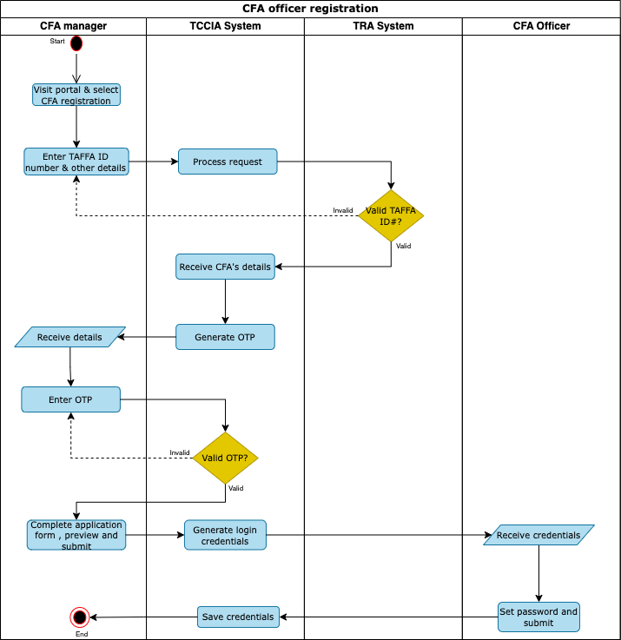

## Membership

### Membership Application

The following is the process flow for membership application

1. The Applicant/TCCIA Agent/TCCIA Officer navigate to membership registration, fill form details including TIN, preview and submit.
2. The system sends TIN to TRA for verification.
3. If valid TIN, the system generates and send OTP and displays Applicant details
4. The Applicant/TCCIA Agent/TCCIA Officer enter OTP and submit or cancel.
5. If cancel, process end.
6. If submit, the system checks the validity of OTP.
7. If valid OTP, the system sends application and notification to respective region based on membership category selected.
8. Membership officer reviews the application. If correct category is selected, the membership officer generate invoice containing control number and notification sent to Applicant. Else, the membership officer engages with the Applicant and make necessary correction followed by generating control number.
9. The applicant make payment.
10. The system generates membership certificate, login credentials and send notification to Applicant.

#### Process flow diagram

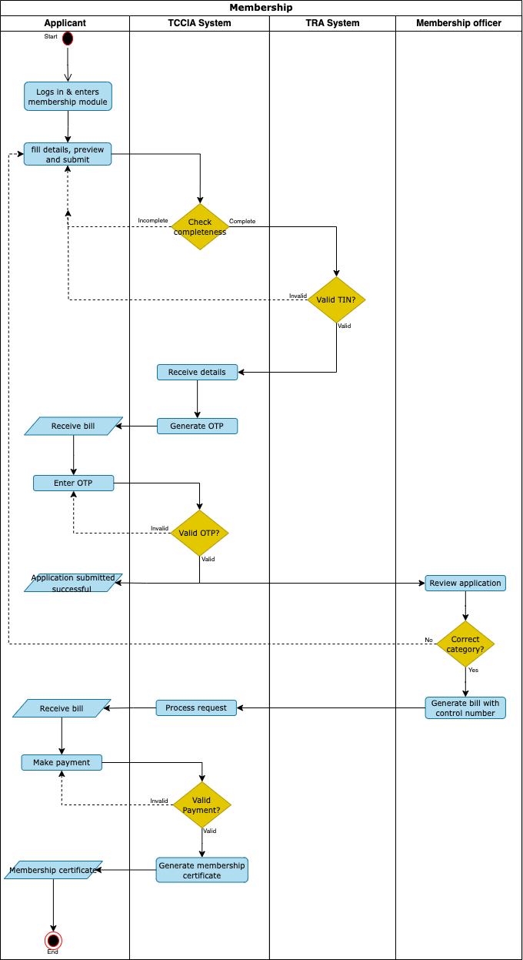

### Membership Renewal/Reinstatement

The following is the process flow for Membership renewal/reinstatement

1. The system allows Applicants to log in using their credentials.
2. The System enable Applicant to request an invoice for renewal/reinstate of membership certificate.
3. The System generate control number for renewal/reinstate of membership certificate.
4. The System generate invoice for renewal/reinstate of membership certificate.
5. The System display generated invoice for download.
6. The System send generated invoice in PDF format to the Applicant e-mail.

#### Process flow diagram



### Managing product and service catalogue

The following is the process flow for managing product and service catalogue

1. The system enables Membership officer to select product and service catalogue.
2. The system enables Membership officer to add, update or remove product(s) and service(s)
3. If adding, the system enables Membership officer to fill out the product and service description form and submit it.
4. If updating, the system enables Membership officer to select product or service to be updated, update selected product or service and submit the request.
5. If removing, the system enables Membership officer to select product or service to be removed from the list and submit the request.
6. The system update product or service and notify all members with membership category containing the updated product or service
7. The system removes selected product or service only if it is not assigned to any membership category, and display notification.

#### Process flow diagram



### Assigning product and service to the membership category

The following is the process flow for assigning product and service to the membership category

1. The system enables Membership manager to select membership category catalogue.
2. The System enables Membership manager to select predefined membership category of a list of membership categories.
3. The system enables Membership manager to select product(s) or service(s) to assign to the selected membership category.
4. The system enables Membership manager to submit form for assignment of product or service to membership category.
5. The system request Membership manager to confirm submission or return back.
6. The system completes the assignment of product or service to membership category if Membership manager confirm submission.
7. The system notifies all members belongs to the updated Membership category.
8. The system returns Membership manager to the previous page if back option is selected.

#### Process flow diagram



### Removing product and service from a given membership category

The following is the process flow for removing product and service from a membership category

1. The system enables Membership manager to select membership category catalogue.
2. The System enables Membership manager to select predefined membership category of a list of membership categories.
3. The system enables Membership manager to remove product(s) and service(s) from selected membership category.
4. The system enables Membership manager to submit and confirm removal of product(s) and service(s) from membership category.
5. The system removes selected product and service from membership category and notify all members belongs to updated membership category if Membership manager confirm submission.
6. The system returns Membership manager to the previous page if back option is selected.

#### Process flow diagram



## Non-Tariff Barrier Management

The following is the process flow for reporting NTB

1. Exporter/Importer/Trader access the appropriate communication channel (SMS, Mobile App or WhatsApp), fill details and submit.
2. The system receives NTB issue, send notification to the corresponding REO of the NTB reporter and HQ NTB Officer.
3. If report NTB need attention of REO, the REO select the relevant GDs to receive the reported NTB.
4. The system send notification to the contact person(s) of the selected GDs to attend the reported NTB.
5. The REO communicate with GD and provide feedback of the reported NTB.
6. If reported NTB need attention of HQ, the HQ NTB Officer select a region and assign the reported NTB.
7. The system enables HQ NTB Officer to forward the reported NTB to the selected GDs
8. The HQ NTB officer communicate with GD and provide feedback of the reported NTB.

#### Process flow diagram

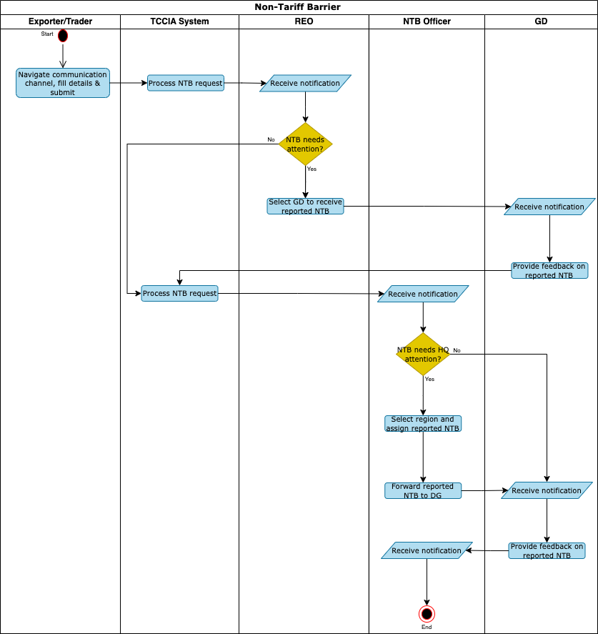

## Complaints handling

The following is the process flow for complaints handling

1. Client navigates to complaint module, select type/category, fill form, upload attachment and submit
2. System generates ticket number, and assign to help desk officer.
3. Help desk officer review complaints, add remarks and assign to respective manager or REO for investigation
4. Manager or REO review complaint and reject with remarks or accept to proceed with investigation
5. If reject, help desk officer reassign complaint to another manager or REO
6. If accept, manager or REO review, add remarks and assign to the TCCIA staff in the unit or region to conduct investigation
7. TCCIA Staff receive complaints, conduct investigation, prepare investigation findings/summary and submit for approval
8. Manager or REO review investigation findings and approve, reject or send back
9. If reject, system send notification to TCCIA staff and client
10. If send back, system return complaint to TCCIA staff for further amendments
11. If approved, system send notification/complaint feedback to Client, TCCIA staff and TCCIA HQ

#### Process flow diagram

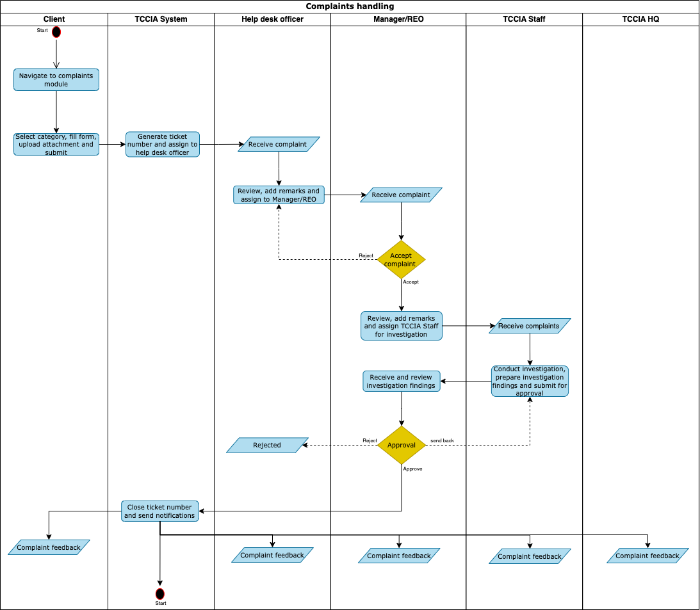

## Handover duties

1. Requestor logs in and enter handover duties/workflow module
2. Requestor select activity(ies) to handover, select period of time and submit for approval.
3. Approval review request and approve or reject.
4. If rejected, Approver enter remarks and notification sent to TCCIA officer.
5. If approved, Approver enter remarks and notification sent to TCCIA officer and who has been handled the activities.
6. Administrator receive notification to change/assign role for specific period.

#### Process flow diagram

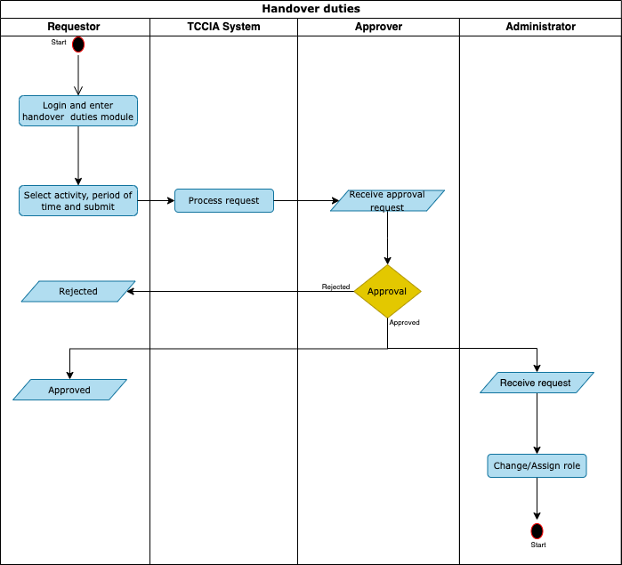

## Billing and Payments

### Bill and Payments

1. Client/Officer login the system and initiate bill for specific service or product(s).
2. System receives bill details such as user id, amount, TIN, expiry date, and remainder schedule for different offered services and products
3. System generates bill reference number with control number based on received details and send to Payment Gateway.
4. Payment gateway returns bill reference with corresponding collection account.
5. The system updates bill details and display/send control number to client.
6. Client receives bill with control number and makes payment.
7. If payment is valid, system generate payment receipt and send to client
8. If invalid payment, system send notification to client

#### Process flow diagram

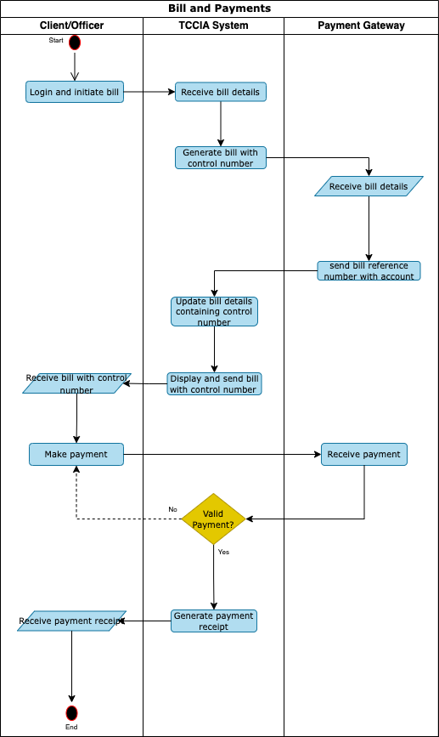

### Bill cancellation

1. TCCIA officer logs in and enter bill and payments module
2. TCCIA officer select/search control number, cancel bill and submit.
3. Responsible head/Accountant review bill cancellation request and approve or reject.
4. If rejected, the system send notification to officer and keep control number as unpaid.
5. If approved, the system cancel bill and send notification to TCCIA officer, payment gateway and TANCIS/Single window corresponding to service.

#### Process flow diagram

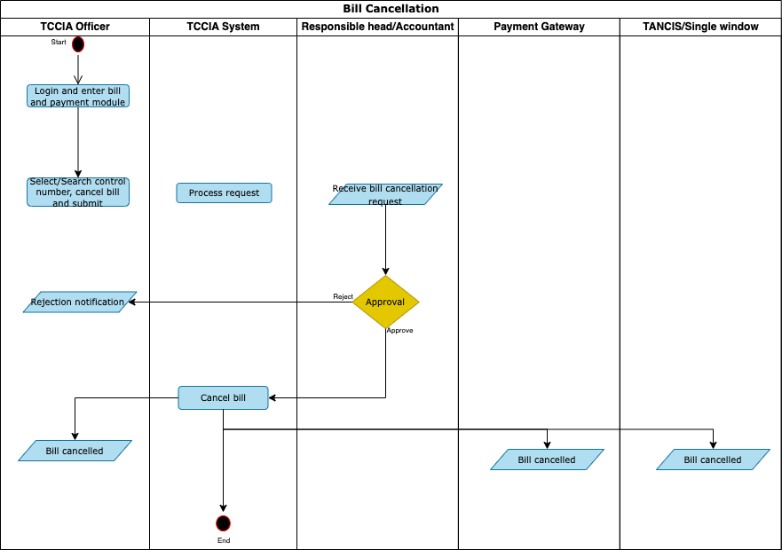

### Identification of Defaulters

1. The system initiates the process every day by checking all of the traders who have failed to meet bill payment deadline.
2. The system gets the current date in order to identify unsettled bills.
3. The Finance Officer searches for a client using demographic information or Membership ID to determine if the trader is already registered as defaulter
4. The system identifies due dates of all of unsettled bills from all expected payments
5. The system checks if the identified unsettled bill payment period is overdue.
6. If the bills are not overdue, the system ends the process.
7. If the bills are overdue, the system creates defaulter(s) that has unsettled bill(s) is overdue.
8. After creating the defaulter(s), the system checks if the expected payment fees have penalty to a defaulting trader.
9. If the expected payment fee has no penalty for defaulter(s), the system ends the process.
10. For expected payment fees that have set penalty to defaulter(s), the system computes the amount based on service

#### Process flow diagram



### Payment Reminder Notification

1. The system initiates the process every day by checking all the pending payments for various services that require sending notifications to traders.
2. The system gets the current date in order to identify the services in the system that requires notifications to be sent to traders.
3. The system checks if the notification date has been reached for all configured services that require sending notification to traders.
4. If the notification date has not reached, the system ends the process.
5. If the notification date is reached, the system sends notification message to relevant traders.

#### Process flow diagram



### Payment Via Prepaid Service

1. The system allow trader to login in the system and selected unsettled bill
2. The system retrieves unsettled bill details based on selected bill
3. The system allow trader to select payment method for clearing the bill
4. The system checks payment channel for clearing the bill
5. If the payment channel is the Payment Gateway, the system calls sub-process of payment and end process
6. If payment channel is Prepaid, the system checks balance of the trader’s account
7. If trader has insufficient prepaid balance, the system notifies on insufficient balance and end the process
8. If trader has sufficient prepaid balance, the system deducts prepaid amount
9. If it is not full payment, the system deducts outstanding balance
10. If it is full payment, the system settles the whole bill
11. The system sends a request to cancel control number
12. The Payment Gateway receive the request and process cancel control number
13. The Payment Gateway notify the system on cancel of control number response
14. If it is not full payment and control number is cancelled, the system generates bill of outstanding balance
15. The system checks if trader is defaulter after cancel control number and bill is settled.
16. If trader is a defaulter and bill is settled, the system remove trader from a list of defaulters and end the process

#### Process flow diagram



# System Constraints

In recognition of the critical role that effective system constraints play in shaping the design and implementation TCP, establishment of considerations to address hardware, software, and environmental constraints should be done.

Recognizing the need for efficient use of technology, TCCIA will identify and mitigate potential issues arising from hardware limitations, software dependencies, and environmental factors. This proactive approach will improve the system's performance, scalability, security, reliability, accessibility, and overall effectiveness.

1. **Hardware Constraints:**
2. Server Specifications:
   * **Constraints:** Limited budget for infrastructure investment, potentially restricting the choice of servers by considering processing power, RAM, storage capacity to run effectively several modules within the system.
   * **Considerations:** Opt for cost-effective server solutions that meet the performance requirements. Consider cloud-based and virtualization solutions for scalability and flexibility without significant upfront investment.
3. Network Infrastructure:
   * **Constraints:** Limited bandwidth and network resources may impact system performance, especially during peak usage periods.
   * **Considerations:** Implement network optimization techniques such as data compression, caching, and content delivery networks (CDNs) to minimize bandwidth usage and improve responsiveness.
4. **Software Constraints:**
5. Programming Languages and Frameworks:
   * **Constraints:** Compliance with existing software standards and regulations may limit the choice of programming languages and frameworks.
   * **Considerations:** Choose widely adopted languages and frameworks with strong community support and proven reliability. Ensure compatibility with existing systems and regulatory requirements.
6. Database Management System (DBMS):
   * **Constraints:** Compatibility with existing database systems and data security regulations.
   * **Considerations:** Select a DBMS that offers robust security features, scalability, and support for structured and unstructured data. Consider no SQL database solutions for flexibility and scalability.
7. **Environmental Constraints:**
8. Operating Environment:
   * **Constraints:**

* Compatibility Requirements: The TCP must be compatible with various operating systems used by stakeholders, including government agencies, businesses, and consumers.
* Regulatory Compliance: The system must be compatible with both Windows and Linux operating systems, and comply with all applicable security protocols, data privacy regulations, and interoperability standards.
* Resource Limitations: Limited hardware resources and technical capabilities of operating systems may constrain system performance, scalability, and functionality.
* Security Vulnerabilities: Vulnerabilities inherent in certain operating systems pose risks to the security and integrity of the TCP, necessitating robust security measures and regular updates to mitigate potential threats.
  + **Considerations:**
* Open Standards: Prioritizing open standards and protocols facilitates interoperability and data exchange between the TCP and stakeholders’ systems, ensuring compatibility with a wide range of operating environments.
* Security Enhancements: Implementing robust security measures, such as encryption, access controls, and intrusion detection systems, mitigates security risks associated with operating system vulnerabilities, safeguarding sensitive data and system integrity.
* Scalability and Performance Optimization: Optimizing system architecture and codebase for performance and scalability enhances responsiveness and efficiency across different operating systems, enabling the TCP to handle increased workloads and user demands effectively. Consider Ubuntu Linux Operating system.

1. Network Conditions:
   * **Constraints:** Limited connectivity and unreliable network infrastructure may affect system accessibility and performance, especially in remote areas.
   * **Considerations:** Prioritize lightweight and efficient communication protocols to minimize network overhead.
2. Security and Privacy Regulations:
   * **Constraints:** Strict data protection laws and regulations mandate robust security measures to safeguard sensitive information.
   * **Considerations:** Implement encryption, access controls, and data anonymization techniques to protect confidentiality and integrity of data. Conduct regular security audits and compliance assessments to identify and address potential vulnerabilities.

By carefully considering and addressing these hardware, software, and environmental constraints, the countries can tailor a standardized system to meet regulatory objectives while ensuring scalability, reliability, and performance.

# Assumptions and Dependencies

The design and development of the TCP will be based on the following assumptions. Dependencies on external services and systems are also detailed below.

1. **Assumptions made during system design:**
   1. **Stakeholder Availability:** TCCIA Officers, Manufacturers, Exporters and CFAs will be available for system training and user testing during scheduled sessions. They will allocate the necessary time and resources to participate actively.

**Rationale:** Successful user training and testing rely on the active involvement of stakeholders. Any unavailability or lack of participation could impact the project's timeline and quality.

* 1. **API Integration Readiness:** Third-party government systems will be available and provide stable well documented APIs for integration.

**Rationale:** Smooth API integration is essential for data exchange. This assumption ensures that the integration process will proceed as planned, minimizing potential delays.

* 1. **Regulatory Stability:** Existing regulation and policy requirements that govern TCCIA business operations will remain stable throughout the project's duration.

**Rationale:** Regulatory stability ensures that the project can proceed without significant changes to compliance requirements, reducing the risk of scope changes.

1. **Dependencies on external systems or services:**
2. **API Integration Dependencies:** The successful integration with third-party government systems, such as TRA and private systems such as payment solutions providers depends on the availability and stability of their APIs.

**Impact:** Any changes or unavailability of these APIs may impact data validation, performance of the system and the project timeline.

1. **Regulatory Dependencies:** Compliance with existing and evolving acts, regulations, procedures, and guidelines related to core TCCIA business processes is a critical dependency. These acts and regulations include business registration act, client service charter, Service Level Agreements (SLAs) and so on.

**Impact:** Changes in regulations may necessitate adjustments to the systems compliance mechanisms, potentially impacting development, and testing efforts.

1. **IT Infrastructure Dependencies:** The project is dependent on the capability of the technical personnel of the IT department to provide the technical support and maintain the necessary technical infrastructure to ensure systems availability and accessibility.

**Impact:** Any delay in establishing necessary ICT supporting infrastructure and tools may impact system availability, performance, and project time line. The supporting infrastructure includes various hardware devices and application software while the ICT supporting tools include various policies and procedures such as ICT policy, ICT security policy, client service charter and so on.

1. **Data Migration Dependencies:** Successful migration of historical data from legacy systems is crucial to ensure business continuity and generation of relevant reports.

Impact: Data migration challenges may affect the availability of historical data and system functionality.

By identifying and acknowledging these assumptions and dependencies, TCCIA can proactively manage risks, anticipate challenges, and ensure the successful implementation and operation of the TCP. Regular monitoring and communication with stakeholders will be crucial for validating assumptions and addressing dependencies throughout the system lifecycle.

# Project Implementation Constraints

1. **Integration Constraints:** The integration with other systems is subject to their API availability. The unavailability of API may affect scope implementation and any changes to their API structure must be promptly addressed to maintain seamless data exchange, which could impact project timelines.
2. **Infrastructure Constraints** The hosting infrastructure must be able to scale horizontally to accommodate an increase in traffic during peak time. This constraint requires the adoption of an infrastructure with auto-scaling capabilities.
3. **User Adoption and Training Constraints:** Manufacturers, Exporters, Traders and CFA (external users) and TCCIA officers (internal users) may not be tech-savvy. To address this, it is recommended to conduct user training sessions and create user-friendly user guide documentation.
4. **Change Management Constraints:** Resistance to change is anticipated among project stakeholders. To address this constraint, a comprehensive change management plan needs to developed during the project implementation, which includes change impact assessments, communication strategies, and user engagement initiative.

# Requirements for Development of TCP

This section details the requirements and needs gathered from TCCIA.

These requirements are categorized as functional and non-functional. Functional requirements describe the system's intended behaviour, specifying the functions it must perform. Non-functional requirements define the overall qualities of the proposed TCP.

## Functional Requirements

This sub - section describes the functional requirements for the TCP, which are important to both users and developers. These requirements were primarily gathered and validated through workshops with the consultant and TCCIA. They will inform the "to-be" business processes outlined in the TCP Requirement Specification report.

### User Registration

This subsection details the functional requirements for user registration. System users can be either clients or staff.

* ***User Class: Applicant***

The following are the requirements corresponding to Applicant.

| **Requirement #** | **Requirement** |
| --- | --- |
|  | The system shall allow applicants to complete and submit user registration information |
|  | The system shall allow registration using a phone number or email (others via NIDA). |
|  | The system shall validate the entered email address or mobile phone |
|  | The system shall be able to generate and send an OTP through mobile phone number provided for verification of user's account |
|  | The system shall be able to be integrated with Personal Identity systems such as TIN (Taxpayer Identification Number) or National ID system (NIDA) for user verification and validation before account creation (For applicants that have NIDA or TIN) |
|  | The system shall allow Applicant to select user categories (personal or company) and roles (Admin, Agent, Client, Consignee, Producer, farmer, Importer, exporter, Employee, trader) |
|  | The system shall allow Applicant to save the application form before submission |
|  | The system shall allow Applicant to submit a completed user registration form |
|  | The system shall allow applicant to change password on the first login |
|  | The system shall allow user to recover the forgotten password |
|  | The system shall allow user to change password anytime when user need to do it.  On the change password window, the user will be required to   * Key in the old password * Key in the new password * Confirm the password |
|  | The system shall send a reminder e-mail to a registered applicant who have not yet submitted their application form. |
|  | The system shall send an email notification to registered applicants upon successful submission of their application |
|  | The system shall send an e-mail notification to applicant to validate account. |
|  | The system shall allow admin to add, disable user, to add and remove role to a user |
|  | The system shall display personal and company details as provided during registration and allow users to view their profile information, including:   * Account details * Company details * Location information |
|  | The system shall provide an "Update Profile" button to allow users to modify their account and company details. Also, the system shall validate the updated information before saving changes. |
|  | The system shall ensure that only authenticated users can access and update their profile information. |
|  | The system shall store all members, traders, agents, and professionals' profiles, including identification, contact details, firm information, and verification details, in a centralized, secure registry. |
|  | The system shall show a pop up with information on how to complete the registration during user registration process |

### Core processes requirements

This section focuses on functional requirements related to TCP processes and how they will be integrated with other systems.

| **Requirement #** | **Requirement** |
| --- | --- |
|  | The system shall enable user to submit user details through user registration from. |
|  | The system shall notify user if submitted details already exist. |
|  | The system shall verify submitted e-mail. |
|  | If e-mail verified, the system shall create user account and send activation link to user e-mail. |
|  | The system shall send notification to user e-mail upon successful account creation. |
|  | The system shall notify user if e-mail is not verified. |
|  | The system shall allow authorized users to initiate the request of a Certificate of Original. |
|  | The system shall auto-fill certificate details from existing records |
|  | The certificate of original shall include: -   * Certificate title (“Certificate of Original”) * Issuer details (e.g., organization name, logo, contact info) * Recipient name or item identifier * Date of issue * Unique certificate number or QR code * Description or statement of originality * Authorized signatory and designation * Digital signature or stamp |
|  | The system shall include a verification mechanism (e.g., unique certificate number or scannable QR code) to validate the authenticity of the certificate. |
|  | The system shall ensure verification should be accessible via a portal or API. |
|  | The system shall provide access to create, approve, and issue certificates to only authorized personnel (e.g., admin, registrar, quality assurance team, inspectors) |
|  | The system shall provide different user roles such as view, create, amend or approval permissions. |
|  | The system shall ensure issued certificates shall be stored securely in the system’s database. |
|  | The system shall enable users to retrieve historical certificates via search (by name, ID, date, or certificate number). |
|  | The system should ensure the certificate(s) printable with high-resolution layout suitable for official use. |
|  | The system shall notify the recipient (via email or portal) once the certificate is issued and ready for download/viewing. |
|  | The system shall log all actions related to the creation, approval, and issuance of certificates for audit purposes. |
|  | The system shall have offline and online mobile application capability. |
|  | The system shall allow users to submit complaints/NTB via:   * Web portal * Mobile app * WhatsApp * Email integration |
|  | The complaint/NTB submission form shall include:   * Complainant’s name and contact information * Complaint/NTB category/type * Description/details of the issue * Supporting documents (attachments) * Date and time of incident |
|  | The system shall automatically assign a unique complaint/NTB reference number. |
|  | The system shall send an acknowledgment notification (email/SMS/portal message) to the complainant. |
|  | The system shall enable NTB Officer to add, update and remove Government Department and contact persons |
|  | The system shall allow classification of complaints/NTB by:   * Type (e.g., service, personnel, technical, NTB) * Severity (e.g., high, medium, low) * Department or responsible team |
|  | The system shall assign complaints/NTB or tasks priority based on predefined business rules or manual override. |
|  | The system shall route the request/complaint/NTB to the appropriate team or department. |
|  | The system shall track the status of each request/complaint/NTB (e.g., Received, In Review, Approved, Inspection, Investigating, Resolved, Closed). |
|  | The system shall allow reassignment/escalation of request to other staff or departments. |
|  | The system shall allow staff add **internal notes**/remarks and updates to the request/complaint. |
|  | The system shall have dashboard to show the summary of each activity such as membership, certificate of original, payments, NTB, and complaints. |
|  | The system shall allow user to upload necessary documents |
|  | The system shall generate reports in different formats such as pdf, excel, table view, kanban view. |
|  | The system shall maintain and keep an audit log of all actions taken include user ID, timestamp, and action performed. |
|  | The system shall allow creation and management of customer profiles with:   * Personal/company information * Contact and billing address * Payment preferences and history * Account balance and credit status |
|  | The system shall automatically generate bills/invoices based on requested service or product. |
|  | The system shall support One-time and recurring billing |
|  | The system shall support invoice delivery via:   * Email (PDF format) * Customer portal (view/download) * SMS link (optional) |
|  | The system shall accept multiple payment methods:   * Mobile wallets through MNO * Bank transfer |
|  | The system shall generate payment receipt upon successful payment as well as email the receipt to the customer, Update the customer’s account balance and Mark the invoice as paid |
|  | The system shall detect and flag failed payments. |
|  | The system shall send reminders for upcoming due date and overdue invoices. |
|  | The system shall apply late fees based on configured rules. |
|  | The system shall generate payment reports for:   * Billing history by customer/date * Payment status (paid, unpaid, overdue) * Revenue and collections * Failed or disputed transactions |
|  | The system shall enable Membership officer to add, update or remove product(s) and service(s) |
|  | The system shall notify all members in that category when product or service has been updated. |
|  | The system shall remove selected product or service only if it is not assigned to any membership category, and display notification. |
|  | The System shall enable Membership manager to add, update or remove membership category(s). |
|  | The system shall notify all members in that category when the category has been updated. |
|  | The System shall enable Membership manager to assign product and services to membership category |
|  | The system shall notify all members belonging to the updated Membership category when a new product or service has been added |
|  | The System shall enable applicant to select region and apply for membership |
|  | The system shall enable applicant to view product and service offered to various membership categories of selected region |
|  | The system shall enable the applicant to preview supplied membership information before confirmation and submission |
|  | The system shall be able to generate membership invoice in pdf format and send to applicant via email |
|  | The System shall generate a softcopy of the TCCIA Membership Certificate in PDF format with a QR code for verification purposes |
|  | The system shall send generated TCCIA Membership certificate in PDF format to Applicant e-mail and other notification via SMS |
|  | The System shall enable business development officer (BDO) to upload business information and schedule publishing to selected social media channel or sharing with selected members |
|  | The system shall enable TCCIA Member to accept or reject (with remarks) business information if it was submitted as an invitation |
|  | The system shall allow members to request for an invoice to renew membership |
|  | The System shall send generate control number, invoice in PDF format and sent to applicant via email |
|  | The system shall allow lost members to request for an invoice to be reinstated |
|  | The system shall allow membership manager to suspend/revoke membership |
|  | The system shall allow officer to register potential members during events who can be turned into full members |
|  | The system shall allow CoO applicant to request for amendment on the CoO certificate.   * If the application is not yet attended, amendment is free * If the applicant has already made payment, the applicant will pay 50% of the certificate fees. |
|  | The system should provide notification /feedback to NTB reporter   * Auto-Reply message when NTB is reported (Delivered) * Assigned (Regulator, EAC Board, AfCFTA, SADC) * Feedback when resolved, rejected |

### Integration Needs

#### Data to be exchanged

Table 5: Data to be exchanged

|  |  |  |
| --- | --- | --- |
| **Institution/System** | **Data to TCP** | **Data From TCP** |
| TRA TANCIS/Single window | * Export Data * Import Data * CFA details | Certificate of Origin |
| TRA TIN | * TIN details | TIN number |
| Other Revenue Authorities (ORA) | Certificate of Origin | Certificate of Origin |
| Payment Gateway (GePG/MNO/Bank) | Payment details | Bill details |
| Emails/SMS | Email  SMS | Email  SMS |
| WhatsApp | NTB/Complaint details | NTB/Complaint details |

The figure below illustrates how the TCP system exchange data with stakeholders’ systems

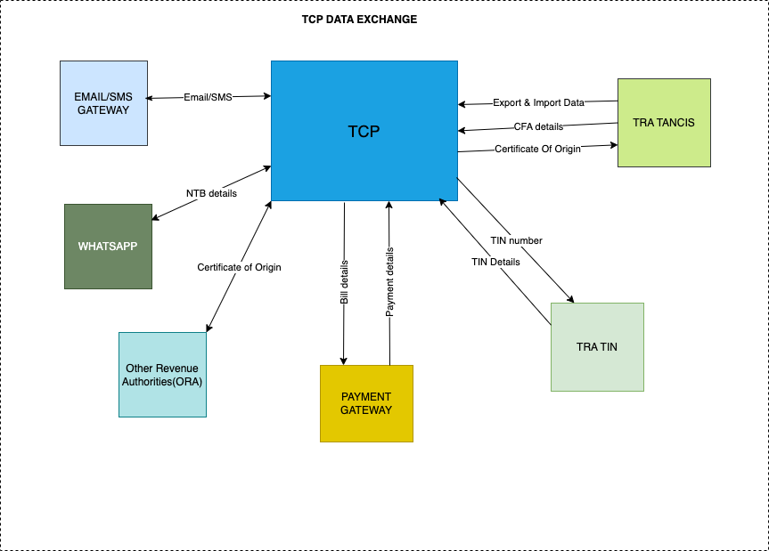

Figure 3: TCP Data exchange with other stakeholders

#### System integration requirements

The following are the requirements corresponding to the System integration with other stakeholders’ systems

| **Requirement #** | **Requirement** |
| --- | --- |
|  | The system shall support the protocols used by the applications you want to integrate, such as SOAP, REST APIs, JMS, or proprietary protocols. |
|  | The system shall be able to transform data between the formats used by different applications (e.g., XML to JSON) during data exchange. |
|  | The system shall be able to route messages to the appropriate destination based on pre-defined rules and orchestrate complex workflows involving multiple applications. |
|  | The system shall provide robust security features such as authentication, authorization, and encryption to protect sensitive data during data exchange. |
|  | The system shall have mechanisms to handle errors gracefully, such as retries, dead-letter queues, and alerting during data exchange. |
|  | The system shall provide comprehensive monitoring and logging capabilities to track performance, identify issues, and ensure smooth operation during data exchange. |
|  | The system shall be able to scale to accommodate increasing message volumes and user demands during data exchange. |
|  | The system shall have low latency and high throughput to handle message processing efficiently during data exchange. |
|  | The system shall be highly available to ensure minimal downtime and uninterrupted service during data exchange. |
|  | The system shall be easy to manage and configure, with user-friendly interfaces and tools to facilitate the configuration how data will be exchanged. |

### System configuration requirements

The system shall be designed to be easily configurable in accordance with the specific laws, regulations within the country and international standards. This configuration requirements shall include, but not be limited to, the following features:

| **Requirement #** | **Requirement** |
| --- | --- |
|  | **Configurable Notification and Alert System:** The system shall allow the configuration of notifications and alerts. |
|  | **Customizable Reporting and Analytics:** The system shall offer customizable reporting tools, enabling users to generate reports based on user’s needs. |
|  | **User-Defined Access Control:** The system shall allow configuration of user roles, permissions, and access rights, enabling tailored access control. |
|  | **Audit Trail and Compliance Monitoring:** The system shall allow the configuration of audit trails and action monitoring. |
|  | **Role-Based Dashboard and Insights:** The system shall provide a configurable dashboard that displays role-specific insights, such as pending approvals, payment status, compliance alerts, and product verification schedules. |
|  | **Parameterization module:** This feature allows users to modify settings or parameters according to specific branch without requiring extensive system changes. |

## Non-Functional Requirements

This section describes non-functional requirements for the System that will be important to users or developers of the TCP. These include performance, security, quality attributes, and business continuity in line with TCCIA Policy.

### Performance Requirements

This section provides performance requirements to be met in order to guarantee systems usability, availability of services and information, and user satisfaction when processing huge and complex data in the TCP.

#### Workload Management

The following are workload management requirements:

|  |  |
| --- | --- |
| **Requirement #** | **Requirement** |
|  | In each processing request, the system shall be able to process 99.9% of transactions in less than 5 seconds in both normal and peak workload conditions. |
|  | The system shall use queuing technologies to enhance processing speed and assurance of data delivery. |
|  | The system shall use caching technologies to shorten request/response time. |
|  | The system shall handle maximum users requests concurrently. |

#### Response Time

The following are system requirements related to response time:

| **Requirement #** | **Requirement** |
| --- | --- |
|  | The system shall allow web page rendering both in standard time and peak time in less than 5 seconds. |
|  | The application server(s) shall be configured to utilize its maximum available number of concurrent connections. |
|  | The enterprise operating system (OS) shall be used to host the application to enhance data processing speed. |
|  | The system shall allow only mandatory processes/services to run in the background in order to boost request response time and internal processing time. |
|  | The system shall have failover mechanism on its components when any fault is detected on the Operating System (OS), Database or application services. |

### Scalability

The following are the system scalability requirements:

|  |  |
| --- | --- |
| **Requirement #** | **Requirement** |
|  | The workload and response time requirements shall be met as the system scale. |
|  | The system shall be designed in a modular structure so as to allow seamless scaling up/down of modules/functionalities without affecting the overall system architecture. |
|  | The system shall allow incorporation of new modules/ functionalities without affecting the overall system performance. |
|  | The system shall allow the reduction of modules/functionalities without affecting the overall system performance. |
|  | The system shall allow configurable modification to accommodate new rules (such as penalty rules, rules of origin, fees, etc.) from application-level settings. |

### Usability

The following are the system usability requirements:

|  |  |
| --- | --- |
| **Requirement #** | **Requirement** |
|  | The system shall be easy to navigate with an intuitive user interface. |
|  | The system shall provide clear and consistent error messages. |
|  | The system shall offer user-friendly documentation and help guides. |
|  | The system shall ensure minimal loading times to enhance user experience. |
|  | The system shall allow for quick and efficient user task completion. |
|  | The system shall support keyboard navigation and screen reader functionality. |
|  | The system shall provide a responsive design for seamless use across different devices (e.g., desktop, mobile). |
|  | The system shall allow for easy retrieval of help or customer support. |
|  | The system shall ensure consistent performance even under high user load. |
|  | The system shall be designed to minimize the learning curve for new users. |

### Platform

The following are the system platform requirements:

| **Requirement #** | **Requirement** |
| --- | --- |
|  | The system shall be hosted on a server computer running an open-source operating system (OS) such as Unix/Linux with guaranteed technical support, utilities updates, and operating system upgrade. |
|  | The maximum allowable CPU utilization shall be 60%, leaving a 40% free space allowable for background processes. |
|  | The maximum allowable CPU load average shall be 0.60 in all 1 minute, 5-minutes, and 15-minutes intervals. |

### System Quality Attributes

This section provides the various non-functional requirements related to quality attributes of the TCP.

#### Availability and Reliability

The following are the availability and reliability requirements:

|  |  |
| --- | --- |
| **Requirement #** | **Requirement** |
|  | The system shall be available to authorized users 24/7 so long as the operating environment does not limit the system operation. |
|  | The system shall not have a single point of failure. |
|  | The precision of calculations shall be at least 1x10-6 |
|  | The system shall not be unavailable for more than 1 hour per 1000 hours of operation. |

#### Backup and Recovery Management

The following are the backup and recovery management requirements:

|  |  |
| --- | --- |
| **Requirement #** | **Requirement** |
|  | The system shall have the facility to enable performing backup that is automatically based on a schedulable frequency to be held at an offsite location so that it is recoverable in the event of a system or hardware failure. |
|  | The system shall provide data recovery facilities to enable a smooth switchover to the backup site. |
|  | The system shall have the ability to resend undelivered messages in case of a problem without introducing any errors. |

#### Maintainability

The system shall be designed and implemented in a manner that promotes ease of recovery from faults. The maintainability factors presented in Table 7 guide maintainability requirements. Some of the identified factors shall be measured on a scale between 1 and 10. A lower score indicates a good maintainability index.

Table 7: Maintainability Requirements Matrix

|  |  |  |  |
| --- | --- | --- | --- |
| **S/N** | **Maintainability Factor** | **Description** | **Scale of measurement** |
| 1 | Modularization Complexity | As complexities increases, so it is difficult to maintain the system. | [1 -10] |
| 2 | Data structure complexity | As complexities increases, so it is difficult to maintain the system. | [1 -10] |
| 3 | Code complexity | As complexities increases, so it is difficult to maintain the system. | [1 -10] |
| 4 | Code Annotation | Well explained code simplifies its maintenance. | N/A |
| 5 | Code size | As code size increases, so it is difficult to maintain the system. | N/A |

The following are maintainability requirements:

|  |  |
| --- | --- |
| **Requirement #** | **Requirement** |
|  | The system shall be designed in a modular manner with at most a 5 scale of modularization factor. |
|  | The system shall be designed in a manner that enhances the application of simple data structures, measurably in a scale not exceeding 5 data structure complexity factors. |
|  | The system shall be implemented with a well-organized code to enhance simplicity, measurably in a scale not exceeding 5 code complexity factors. |
|  | The system shall be implemented with a well-annotated code. |
|  | The system shall be implemented with minimal code as possible. |

#### Portability

The following are portability requirements:

|  |  |
| --- | --- |
| **Requirement #** | **Requirement** |
|  | The system shall support client access through all major browsers. |
|  | The system shall accommodate localization/ internationalization and correctly interpret local languages where the software is being used, recommended English and Swahili languages. |
|  | The system shall be able to adapt to the standard mobile device displays and interfacing. |

### Testing Requirement

The following is the testing requirement:

|  |  |
| --- | --- |
| **Requirement #** | **Requirement** |
|  | The system shall be tested using the following types of testing: unit testing, integration testing, and user acceptance testing as defined in the general domain of knowledge. |

### System Administration, Security and Management Requirements

This section provides the various non-functional requirements related to quality attributes of the TCCIA system.

#### System Administration

The following are the system administration requirements:

|  |  |
| --- | --- |
| **Requirement #** | **Requirement** |
|  | The system shall have user management module for creation of users, groups, roles, login and password management etc. |
|  | The system shall allow analysis of Audit Trail data for security purpose |
|  | The system shall have an error management mechanism that provides Correction of user errors/mistakes using best available technology |
|  | The system shall be capable of being configured for secure operation in its intended environment(s), and must report any deficiencies that preclude its complete configuration |
|  | The system shall comply to the principle of separation of duties. |

#### System Security

 The following are the system security requirements:

| **Requirement #** | **Requirement** |
| --- | --- |
|  | The system shall be capable of performing data authentication using the best latest methods and be flexible to adopt future improvements. |
|  | The system shall support the best Digital Signature Standard (DSS). |
|  | The system shall use standard password-based key derivation function. |
|  | The system shall use Keyed hash function as the core hash inside password- based key functions |
|  | The system shall be able provide the capability to increase number of password iterations |
|  | The system shall Store the iteration count, the salt and the final hash in the password database |
|  | The system shall increase the iteration count regularly to keep up with faster cracking tools |
|  | The system shall provide Identification and Authentication (I&A) mechanism that enable an application administrator to configure the maximum number of login attempts. |
|  | The system shall provide I&A mechanism that enable application administrators to configure the duration of the “lockout” period during which a user (or role) who exceeds the number of allowable login attempts will be prevented from making another I&A attempt. |
|  | The system shall encrypt user passwords and any other sensitive I&A data before transmission over a network so as to protect the information that will be accessed after the user is authenticated |
|  | The system shall provide privileged accounts managed by accounts management System which provides functionalities such as password vault, check-in and checkout (e.g. one-time password), audit logging, policy control and account lifecycle management. |
|  | The system shall provide a mechanism for creating and modifying authorization information/ rights (e.g., Access Control List (ACLs), active accounts). |
|  | The system shall comply with Policy-Based Access Control (PBAC) and Role-Based Access Control (RBAC) for authorizing user privileges in conjunction with its discretionary and mandatory data access control schemes |
|  | The system shall enable the creation of different user groups, and the assignment of different roles and privileges/right to each group. |
|  | The system shall provide confidentiality of data manipulated, stored, or transmitted. |
|  | The system shall provide Application Program Interface (API) that enables the application to invoke an encryption capability to selectively encrypt data and files while interacting with other system. |
|  | The system shall ensure all sensitive data stored in database or configuration files are encrypted. |
|  | The system shall use a certified and approved technology to implement a hash of data before transmission. |
|  | The system shall provide data availability guarantees to ensure data are not deleted or overwritten by application malfunction. |
|  | The system shall contain an error exception handling capability so that the application executable files and data will not become vulnerable in case of an application processing failure. |
|  | The system shall provide application’s error handling mechanism that shall be configurable to allow the application to respond according to the detected error. |
|  | The system shall provide error/exception handling capability with error/failure log, error type and error description of all errors and failure events. |
|  | The system shall log all security-relevant events (configured by the application security administrator) to its own secure audit/event log. |
|  | The system shall allow the application security administrator to select the events to be logged and the information to be captured about each event. |
|  | The system shall allow all deleted data be removed from user’s view but available for security review purpose. |
|  | The system shall log and notify security/audit administrators the relevant types of events to its audit facility. |
|  | The system shall keep any subsequent changes to that data from its original content that will be recorded with respective user details for individual accountability. |
|  | The system shall be able to detect, prevent, correct and audit SQL injection; Parameter tempering; Hidden manipulations; Backdoors and debug option; Buffer overflow; Stealth command; Cross-site scripting; Forceful browsing and malicious software. |
|  | The application shall mitigate against all Open Web Application Security Project (OWASP) listed Vulnerabilities that are being faced by web applications. |
|  | The system shall provide storage of encrypted Passwords Directly in the User Store. |
|  | The system shall provide Protection of Access to Credential Store. |
|  | The system shall provide efficient web service authorization, validation, message security, transport security mechanisms. |
|  | The system shall maintain time-stamped with IP address audit logs on a separate server to uniquely trace transactions such as addition, modification or deletion. |
|  | The system shall support the authentication of individual users, not groups. |
|  | The system shall use strong encrypted passwords and store them in an encrypted format using the strongest hashing algorithm. |
|  | The system shall support the creation of long and complex passwords. Such as the use at least 8 characters long, alphanumeric, uppercase, and lowercases. |
|  | The system shall lock the user ID after a maximum of three logon failures. |
|  | The system shall force the user to change initial passwords before they can access any authorized module. |
|  | The system shall not display the password as it is typed in. |
|  | The system shall not allow reuse of the same password until a cycle of five different passwords is completed, and maximum reuse shall be three times. |
|  | The system shall support definitions of unlimited roles and assigned levels of access, viewing, entry, editing, and auditing. |
|  | The system shall restrict the modification of sensitive data to undergo two levels of origination and verification. |
|  | The system shall permit the management of user accounts and their access roles. It will provide tools for creating the accounts, deleting them, updating user information, resetting passwords, and removing locks from locked accounts. |
|  | The system shall not allow multiple login sessions of the same user at the same time. |
|  | The system shall disconnect a logon session automatically after five minutes of inactivity. |
|  | The system shall terminate the existing session when the user logs out. |

#### Virus, Spam-ware and Spy-ware Protection

The following are the system protection requirements:

|  |  |
| --- | --- |
| **Requirement #** | **Requirement** |
|  | The system shall provide web service proxy that shall consider the following requirements.  1. The web service shall publish metadata over HTTPS to protect clients from proxy spoofing.  2. The web service shall implement mutual authentication to avoid service spoofing. |
|  | The system shall facilitate web service auditing and logging. |
|  | The system shall protect sensitive data which refers to confidential information that web service processes, transmits, or stores. |
|  | The system shall work with common software anti-virus packages to ensure the operation of the system is uninterrupted by virus, spam-ware or spy-ware infections. |
|  | The system shall allow all publicly accessible sections of the system sufficiently protected against viruses, worm, spam-ware, hackers and spy-ware attacks. |

# Appendices

## Reports Specifications

|  |  |  |
| --- | --- | --- |
| **SN** | **Report Name** | **Filter By** |
|  | Membership Report | Region, District, Farm, Production Year |
| * + - 1. Conversion Rates   The percentage of prospects who become actual members  Identifying which recruitment channels or campaigns have the highest conversion rates will guide the allocation of resources and budget toward the most effective strategies.   * + - 1. Cost per Acquisition (CPA)   The cost incurred to acquire a new member  Evaluating the efficiency of different recruitment methods. Lowering the CPA is a strategic goal to maximize the return on investment.   * + - 1. Source of Membership   Where new members learned about the organization (e.g., website, events, referrals).  Identifies the most successful channels. A higher influx from specific sources will suggest focusing efforts on those channels.   * + - 1. Demographic Data   Information about the characteristics of new members (e.g., age, industry, location).  Helps in tailoring membership offerings to the preferences and needs of specific demographics   * + - 1. Retention Rate   (Number of Members at the End of a Period - New Members Acquired During the Period) / Number of Members at the Start of the Period) * 100  This provides a percentage that represents the proportion of members retained over a specific period.   * + - 1. Churn Rate   (Number of Members Lost During a Period / Average Number of Members During the Period) * 100  This is the inverse of the retention rate and represents the percentage of members lost.   * + - 1. Membership Renewal Rate   (Number of Members Renewing Membership / Total Number of Members Eligible for Renewal) * 100  This measures the percentage of members who choose to renew their memberships.   * + - 1. Membership Satisfaction Rate (MSR)   Definition:  The Membership Satisfaction Rate (MSR) is a quantitative measure that reflects the consistency of a member’s financial engagement with TCCIA over the entire duration of their membership. It is calculated as the ratio of the total time (in months or years) a member has paid their membership fees to the total time they have remained registered as a member with TCCIA, expressed as a percentage. |
|  | Coo reports | Facility type, region, district, year |
|  | Exports information reports | System should be able to generate/show   * + 1. Regional exports     2. Export information |
|  | Exporters & importers reports | System should be able generate/show   * + 1. Exporters list     2. importers list |
|  | Basic information reports | System should be able to generate/show   * + 1. Product description     2. Customs tariff heading     3. Origin criterion |
|  | Lookup information reports | System should be able to generate/ show   * + 1. Export certificate types     2. Packaging types     3. Export transport modes     4. Exporters account status     5. Export status identity     6. Weight measurements     7. Exporting currency |
|  | Location information reports | System should be to generate/show   1. Exporting countries 2. Export regions 3. Export districts |
|  | System information reports | System should be to generate/Show   1. System Statistics 2. Regional Statistics 3. My Account Profile 4. Export Queries |
|  | NTB/Complaints Reports | Type, region, district, period, assigned to, attended by |
| * + - 1. System should be able to generate/show NTB cases received  1. Cases Information 2. Incident Information 3. Received Messages 4. Sent Responses 5. View GeoData 6. System Statistics    * + 1. Should show basic information 7. NTB Categories 8. NTB Classifications 9. NTB Specifications 10. Reported Institution 11. Country of Incident 12. NTB Regions 13. NTB Districts 14. NTB Locations 15. Case Status     * + 1. Should generate/show user information 16. My Account Profile 17. User Roles 18. Users Details 19. Show Reported Institutions 20. Show An Institution list |
|  | Billing and Payments Report | Bill type, Payment gateway, period, payment status, Region, District  The following are reports needed to be shown/generated  1. Billing Reports   1. Invoice Summary Report    * Summary of all invoices issued during a period.    * Includes invoice number, date, customer, amount, status (paid/unpaid). 2. Detailed Invoice Report    * Itemized details for each invoice.    * Includes products/services billed, tax, discounts, and total per item. 3. Recurring Billing Report    * Overview of customers/accounts with recurring charges.    * Billing frequency, next billing date, amount. 4. Unbilled Charges Report    * Lists charges incurred but not yet invoiced.    * Useful for month-end or project-based billing. 5. Credit/Debit Memo Report    * Records of adjustments, refunds, or credits applied to invoices. 6. Billing Error Report    * Highlights failed or incorrect billing attempts.    * Includes error types, root causes, and affected customers.   2. Payments Reports   1. Payment Summary Report    * Overview of all payments received in a selected period.    * Shows payment date, method (credit card, bank transfer, etc.), and customer name. 2. Customer Payment History Report    * Payment timelines for individual customers.    * Useful for analyzing customer payment behavior and creditworthiness. 3. Outstanding Payments / Aged Receivables Report    * Lists unpaid invoices categorized by aging buckets (e.g., 0–30, 31–60 days).    * Crucial for collections and cash flow forecasting. 4. Failed Payments Report    * Displays unsuccessful payment attempts and reasons (e.g., insufficient funds, card expired). 5. Refund Report    * Details of any refunded payments, including reason, method, and associated invoice. 6. Payment Reconciliation Report    * Matches payments received with corresponding invoices.    * Identifies mismatches or over/underpayments.   3.Combined or Advanced Reports   1. Billing vs. Collection Trend Report    * Visualizes trends in billed amounts vs. collected payments over time. 2. Cash Flow from Billing Activities    * Reflects inflows and outflows directly related to billing and payments. 3. Dispute and Resolution Report    * Tracks disputes related to billing and how they were resolved (discounts, corrections, etc.).   Or can be categorized as per below table |

**Billing and Payments Reports by Department**

| **Report Name** | **Description** | **Used By** | **Frequency** |
| --- | --- | --- | --- |
| Invoice Summary Report | Summary of all invoices issued within a time period. | Finance, Accounting | Weekly / Monthly |
| Detailed Invoice Report | Itemized invoice breakdown including tax, discounts, and services. | Accounting, Sales Ops | As needed |
| Recurring Billing Report | Lists active recurring charges with billing cycles and next bill dates. | Subscription/Revenue Team | Monthly |
| Unbilled Charges Report | Shows charges incurred but not yet invoiced. | Finance, Project Teams | Monthly / Quarterly |
| Credit/Debit Memo Report | Documents adjustments to billing, like refunds or discounts. | Finance, Customer Service | Monthly |
| Billing Error Report | Identifies failed or incorrect billing entries. | IT, Billing Operations | Weekly |

|  |  |  |  |
| --- | --- | --- | --- |
| **Report Name** | **Description** | **Used By** | **Frequency** |
| Payment Summary Report | High-level view of all received payments. | Finance, CFO Office | Daily / Weekly |
| Customer Payment History Report | Tracks payment patterns and history by customer. | Customer Service, Sales | On Request |
| Outstanding Payments Report | Lists unpaid invoices, often categorized by age (A/R Aging). | Collections, Finance | Weekly / Monthly |
| Failed Payments Report | Details unsuccessful payments and failure reasons. | IT, Billing, Finance | Weekly |
| Refund Report | Shows all payment refunds, reasons, and impacted accounts. | Finance, Compliance | Monthly |
| Payment Reconciliation Report | Matches invoices with payments to ensure accuracy. | Accounting, Auditors | Monthly / Quarterly |

| **Advanced/Combined Reports** | **Description** | **Used By** | **Frequency** |
| --- | --- | --- | --- |
| Billing vs. Collections Trend | Compares billed revenue to actual collections over time. | CFO, Finance Strategy | Monthly / Quarterly |
| Cash Flow from Billing Activities | Measures cash inflow from invoicing activities. | Finance, Treasury | Monthly |
| Dispute and Resolution Report | Summarizes customer billing disputes and resolutions. | Customer Support, Legal | Monthly |